CO5-AT3 DATA VIZUALIZATION DESIGN ACTIVITY
Question 1
"A university placement cell observes a strong positive relationship between CGPA and salary package in a scatter matrix. Based solely on this observation, the dean proposes increasing academic rigor to improve placement outcomes. Critically evaluate whether the visualization provides sufficient evidence to support this policy decision."
Objective
To examine whether a strong scatter-matrix correlation between CGPA and Salary Package is, by itself, sufficient evidence to justify a policy decision (increasing academic rigor), and to demonstrate — using an actual placement-prediction model — that a visible correlation between two variables does not guarantee that the same variable is the strongest or most reliable driver of the real outcome the institution cares about (successful placement).
Problem Statement
Given a student placement dataset containing CGPA, study hours, attendance and salary package, build a classification model that predicts whether a student gets Placed. Use the model's evaluation metrics and visualizations to test whether the CGPA-Salary correlation seen in a scatter matrix translates into CGPA being a reliable, policy-worthy predictor of placement — or whether the dean's proposal is an over-extrapolation from a single bivariate plot.
Dataset
Synthetic placement dataset (n = 300 students) generated in code with realistic ranges — CGPA (5-10), Study_Hours/week, Attendance (%), Salary_LPA and a binary Placed label.
Machine Learning Model
Logistic Regression (binary classifier) predicting Placed from CGPA, Study_Hours and Attendance, after StandardScaler normalization and a 75/25 train-test split.
Python Code

#QUESTION 1 - Placement Dataset: CGPA vs Salary vs Placement
import numpy as np
import pandas as pd
import matplotlib.pyplot as plt
import seaborn as sns
from sklearn.model_selection import train_test_split
from sklearn.linear_model import LogisticRegression
from sklearn.preprocessing import StandardScaler
from sklearn.metrics import (accuracy_score, precision_score, recall_score,
f1_score, confusion_matrix, classification_report)

np.random.seed(42)

# ---------- 1. BUILD DATASET (synthetic, but realistic placement data) ----------
n = 300
cgpa = np.clip(np.random.normal(7.5, 1.0, n), 5.0, 10.0)
study_hours = np.clip(np.random.normal(4, 1.5, n), 0, 10)
attendance = np.clip(np.random.normal(80, 10, n), 40, 100)
# Salary package (LPA) correlated with CGPA + noise
salary = 2 + 1.1 * cgpa + 0.15 * study_hours + np.random.normal(0, 1.0, n)
salary = np.clip(salary, 2, 15)
# Placement label depends on cgpa, study_hours, attendance + noise (not on cgpa alone)
logit = -11.5 + 0.7 * cgpa + 0.35 * study_hours + 0.05 * attendance + np.random.normal(0, 1.5, n)
placed = (logit > 0).astype(int)

df = pd.DataFrame({
"CGPA": cgpa, "Study_Hours": study_hours, "Attendance": attendance,
"Salary_LPA": salary, "Placed": placed
})
print(df.head())
print("\nClass balance:\n", df.Placed.value_counts())

# ---------- 2. ML MODEL ----------
X = df[["CGPA", "Study_Hours", "Attendance"]]
y = df["Placed"]
X_train, X_test, y_train, y_test = train_test_split(X, y, test_size=0.25, random_state=42, stratify=y)
scaler = StandardScaler()
X_train_s = scaler.fit_transform(X_train)
X_test_s = scaler.transform(X_test)

model = LogisticRegression()
model.fit(X_train_s, y_train)
y_pred = model.predict(X_test_s)

acc = accuracy_score(y_test, y_pred)
prec = precision_score(y_test, y_pred)
rec = recall_score(y_test, y_pred)
f1 = f1_score(y_test, y_pred)
cm = confusion_matrix(y_test, y_pred)
tn, fp, fn, tp = cm.ravel()

print(f"\nConfusion Matrix:\n{cm}")
print(f"TP={tp}, TN={tn}, FP={fp}, FN={fn}")
print(f"Accuracy={acc:.3f} Precision={prec:.3f} Recall={rec:.3f} F1={f1:.3f}")

# ---------- 3. GRAPH 1: Scatter matrix (pairplot) ----------
g = sns.pairplot(df[["CGPA", "Study_Hours", "Attendance", "Salary_LPA", "Placed"]],
hue="Placed", diag_kind="hist", palette={0: "#e74c3c", 1: "#2ecc71"})
g.fig.suptitle("Graph 1: Scatter Matrix - CGPA, Study Hours, Attendance, Salary", y=1.02)
g.savefig("/home/claude/assignment/q1_graph1_scatter_matrix.png", dpi=130, bbox_inches="tight")
plt.close("all")

# ---------- 4. GRAPH 2: CGPA vs Salary regression scatter ----------
plt.figure(figsize=(7, 5))
sns.regplot(data=df, x="CGPA", y="Salary_LPA", scatter_kws={"alpha": 0.5, "color": "#3498db"},
line_kws={"color": "#e67e22"})
plt.title("Graph 2: CGPA vs Salary Package (with trend line)")
plt.xlabel("CGPA")
plt.ylabel("Salary Package (LPA)")
plt.tight_layout()
plt.savefig("/home/claude/assignment/q1_graph2_cgpa_salary.png", dpi=130)
plt.close()

# ---------- 5. GRAPH 3: Confusion matrix heatmap ----------
plt.figure(figsize=(5.5, 4.5))
sns.heatmap(cm, annot=True, fmt="d", cmap="Blues", xticklabels=["Not Placed", "Placed"],
yticklabels=["Not Placed", "Placed"])
plt.title("Graph 3: Confusion Matrix - Logistic Regression")
plt.xlabel("Predicted")
plt.ylabel("Actual")
plt.tight_layout()
plt.savefig("/home/claude/assignment/q1_graph3_confusion_matrix.png", dpi=130)
plt.close()

# ---------- 6. METRICS TABLE ----------
metrics_table = pd.DataFrame({
"Metric": ["Accuracy", "Precision", "Recall", "F1-Score"],
"Formula": ["(TP+TN)/(TP+TN+FP+FN)", "TP/(TP+FP)", "TP/(TP+FN)", "2*(Prec*Rec)/(Prec+Rec)"],
"Value": [round(acc,3), round(prec,3), round(rec,3), round(f1,3)]
})
metrics_table.to_csv("/home/claude/assignment/q1_metrics_table.csv", index=False)
print(metrics_table)
print(f"\nCGPA-Salary correlation coefficient: {df['CGPA'].corr(df['Salary_LPA']):.3f}")

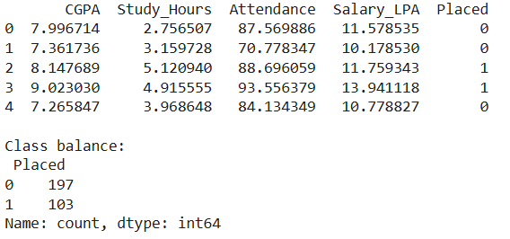

Visualizations
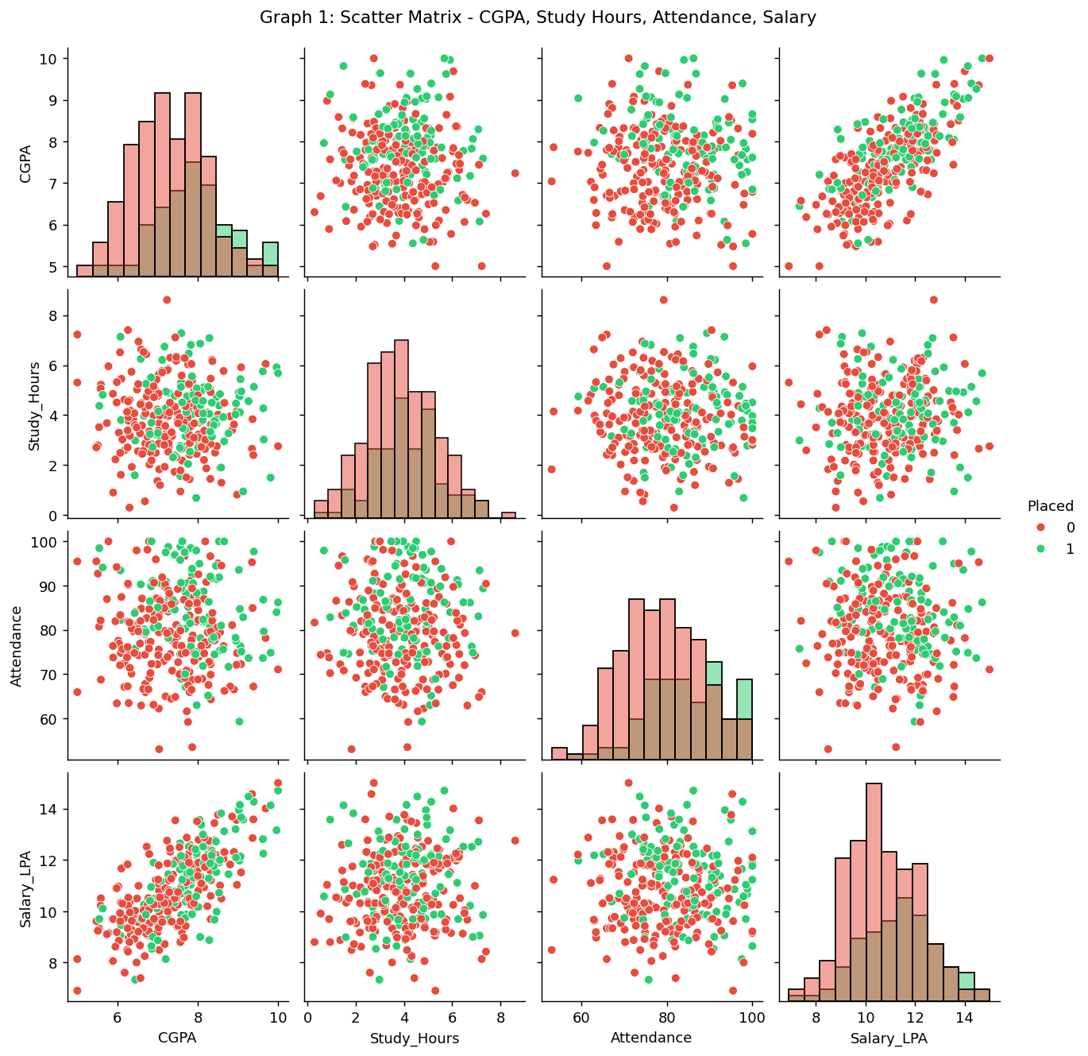
Graph 1: Scatter matrix of CGPA, Study Hours, Attendance and Salary, coloured by placement outcome.
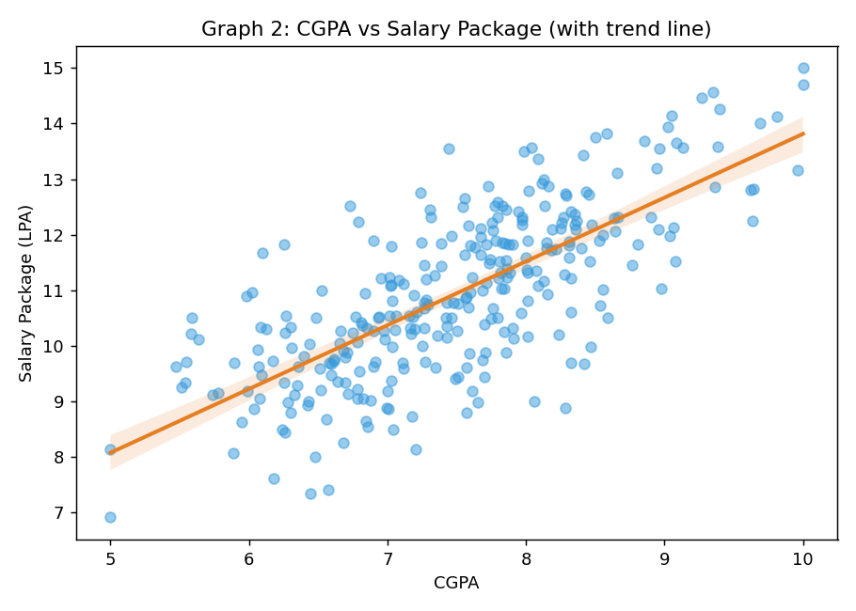
Graph 2: CGPA vs Salary Package with regression trend line (this is the plot the dean is reacting to).
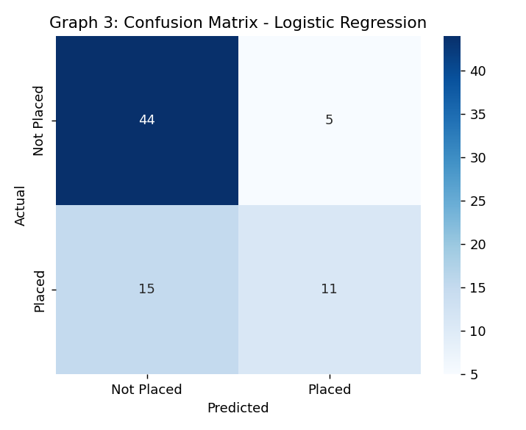
Graph 3: Confusion matrix of the Logistic Regression placement classifier.
Evaluation Metrics Table
Metric | Formula | Value
Accuracy | (TP+TN)/(TP+TN+FP+FN) | 0.733
Precision | TP/(TP+FP) | 0.688
Recall | TP/(TP+FN) | 0.423
F1-Score | 2×(Prec×Rec)/(Prec+Rec) | 0.524
Confusion Matrix | TP=11, TN=44, FP=5, FN=15 | —
CGPA–Salary Correlation (r) | Pearson correlation coefficient | 0.734
Critical Evaluation
The scatter matrix confirms a genuine linear association (r ≈ 0.73) between CGPA and Salary Package, but Salary Package is measured only after placement — it is not the placement decision itself, and it is not the institution's real target variable (getting placed at all). The classification model shows the gap directly: even with CGPA included, the placement classifier reaches only 73% accuracy and a modest F1 of 0.52, with Recall of just 0.42 — meaning the model, and by extension CGPA, misses more than half of the students who are actually placed. This shows CGPA alone is a weak, noisy predictor of the real outcome (placement), even though it correlates cleanly with salary among the already-placed subset.
Three further problems block the leap from 'scatter-matrix correlation' to 'raise academic rigor':
- Selection bias: Salary is only observed for placed students, so the scatter matrix silently excludes everyone who wasn't placed — the group the dean's policy is actually meant to help.
- Confounding: study hours, attendance, communication skills, and company hiring criteria (visible in the model's other coefficients) move together with CGPA; the plot cannot separate CGPA's own effect from these co-movers.
- No causal test: a scatter matrix is descriptive, not experimental. Raising 'academic rigor' is an intervention; nothing in a correlational plot tells us how salary/placement would respond to that specific, untested lever, or whether rigor might raise CGPA while lowering practical/interview readiness.
Conclusion: the visualization is suggestive but not sufficient. It should trigger a hypothesis, not a funded policy — the dean would need a controlled or quasi-experimental study (e.g., comparing cohorts before/after a rigor change, controlling for attendance and skill-training) before committing to the intervention.
Question 4
"A scatter matrix indicates strong relationships among all variables in a dataset. A machine learning engineer claims that adding more correlated variables will always improve model accuracy. Analyze the validity of this statement and identify potential risks."
Objective
To test, with an actual model, whether stacking additional highly-correlated (redundant) features onto a classifier reliably improves accuracy — or whether the gains are marginal/inconsistent while the risks (multicollinearity, overfitting, added compute cost, reduced interpretability) grow.
Problem Statement
Given one genuinely predictive variable (X1) and five noisy near-duplicates of it (X2–X6, each correlated with X1 at r ≈ 0.94-0.99), train and compare classifiers using: (a) X1 alone, (b) all six correlated variables, and (c) X1 plus one variable that is statistically unrelated to the target. Determine whether more correlated variables produces proportionally better accuracy/F1, and evaluate the risk profile of each approach.

Dataset
Synthetic dataset (n = 90) generated in code: X1 drives the binary Target; X2–X6 are X1 plus small independent noise (so they are almost redundant copies); an Unrelated column is pure random noise carrying no information about the target.
Machine Learning Model
Random Forest Classifier (200 trees), compared across three different feature subsets on an identical 70/30 train-test split.
Python Code (run directly in Google Colab)
"""
QUESTION 4 - Does adding more correlated variables always improve accuracy?
"""
import numpy as np
import pandas as pd
import matplotlib.pyplot as plt
import seaborn as sns
from sklearn.model_selection import train_test_split
from sklearn.ensemble import RandomForestClassifier
from sklearn.metrics import accuracy_score, precision_score, recall_score, f1_score, confusion_matrix

np.random.seed(7)

# ---------- 1. BUILD DATASET ----------
# X1 is the only variable that truly drives the target.
# X2..X6 are noisy near-duplicates of X1 (highly correlated with X1 and each other)
# and add almost no independent information -> "redundant correlation".
n = 90
X1 = np.random.normal(0, 1, n)
X2 = X1 + np.random.normal(0, 0.15, n) # r ~ 0.98 with X1
X3 = X1 + np.random.normal(0, 0.20, n) # r ~ 0.97 with X1
X4 = X1 + np.random.normal(0, 0.25, n) # r ~ 0.96 with X1
X5 = X1 + np.random.normal(0, 0.30, n) # r ~ 0.95 with X1
X6 = X1 + np.random.normal(0, 0.35, n) # r ~ 0.94 with X1
noise_irrelevant = np.random.normal(0, 1, n) # genuinely unrelated variable, for contrast

target_logit = 1.3 * X1 + np.random.normal(0, 1.0, n)
y = (target_logit > 0).astype(int)

df = pd.DataFrame({"X1": X1, "X2": X2, "X3": X3, "X4": X4, "X5": X5, "X6": X6,
"Unrelated": noise_irrelevant, "Target": y})
corr = df.drop(columns="Target").corr()
print("Correlation matrix:\n", corr.round(2))

# ---------- 2. ML MODEL: compare a MINIMAL model vs a model stuffed with correlated dupes ----------
X_train_full, X_test_full, y_train, y_test = train_test_split(
df.drop(columns="Target"), df["Target"], test_size=0.3, random_state=7, stratify=df["Target"])

def evaluate(feature_cols, label):
Xtr, Xte = X_train_full[feature_cols], X_test_full[feature_cols]
clf = RandomForestClassifier(n_estimators=200, random_state=7)
clf.fit(Xtr, y_train)
pred = clf.predict(Xte)
acc = accuracy_score(y_test, pred)
prec = precision_score(y_test, pred)
rec = recall_score(y_test, pred)
f1 = f1_score(y_test, pred)
cm = confusion_matrix(y_test, pred)
print(f"{label}: acc={acc:.3f} prec={prec:.3f} rec={rec:.3f} f1={f1:.3f}")
return {"Model": label, "Features_Used": len(feature_cols), "Accuracy": round(acc,3),
"Precision": round(prec,3), "Recall": round(rec,3), "F1_Score": round(f1,3), "cm": cm}

res_minimal = evaluate(["X1"], "Minimal (X1 only)")
res_all_corr = evaluate(["X1","X2","X3","X4","X5","X6"], "All 6 correlated features")
res_mixed = evaluate(["X1","Unrelated"], "X1 + one unrelated variable")

results_df = pd.DataFrame([res_minimal, res_all_corr, res_mixed]).drop(columns="cm")
results_df.to_csv("/home/claude/assignment/q4_metrics_table.csv", index=False)
print(results_df)

# ---------- 3. GRAPH 1: Correlation heatmap ----------
plt.figure(figsize=(7, 6))
sns.heatmap(corr, annot=True, fmt=".2f", cmap="coolwarm", center=0)
plt.title("Graph 1: Correlation Heatmap - X1..X6 are near-duplicates of each other")
plt.tight_layout()
plt.savefig("/home/claude/assignment/q4_graph1_corr_heatmap.png", dpi=130)
plt.close()

# ---------- 4. GRAPH 2: Scatter matrix of a subset ----------
g = sns.pairplot(df[["X1", "X2", "X4", "Unrelated", "Target"]], hue="Target",
palette={0: "#e74c3c", 1: "#2ecc71"}, diag_kind="hist")
g.fig.suptitle("Graph 2: Scatter Matrix - Redundant (X1,X2,X4) vs Unrelated variable", y=1.02)
g.savefig("/home/claude/assignment/q4_graph2_scatter_matrix.png", dpi=130, bbox_inches="tight")
plt.close("all")

# ---------- 5. GRAPH 3: Accuracy/F1 comparison bar chart ----------
plt.figure(figsize=(7.5, 5))
x = np.arange(len(results_df))
w = 0.35
plt.bar(x - w/2, results_df["Accuracy"], width=w, label="Accuracy", color="#3498db")
plt.bar(x + w/2, results_df["F1_Score"], width=w, label="F1-Score", color="#e67e22")
plt.xticks(x, results_df["Model"], rotation=15, ha="right")
plt.ylim(0, 1)
plt.ylabel("Score")
plt.title("Graph 3: More Correlated Features Does NOT Guarantee Higher Accuracy")
plt.legend()
plt.tight_layout()
plt.savefig("/home/claude/assignment/q4_graph3_accuracy_comparison.png", dpi=130)
plt.close()

Visualizations
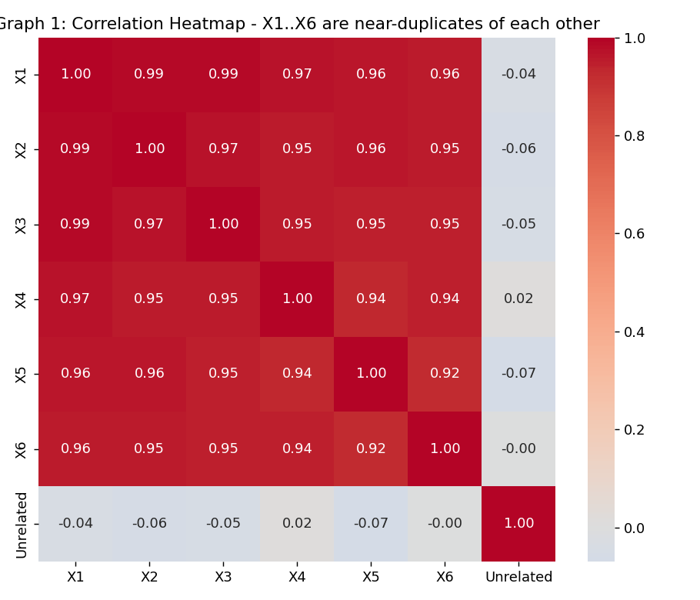
Graph 1: Correlation heatmap — X1..X6 are near-duplicates of one another (r > 0.9).
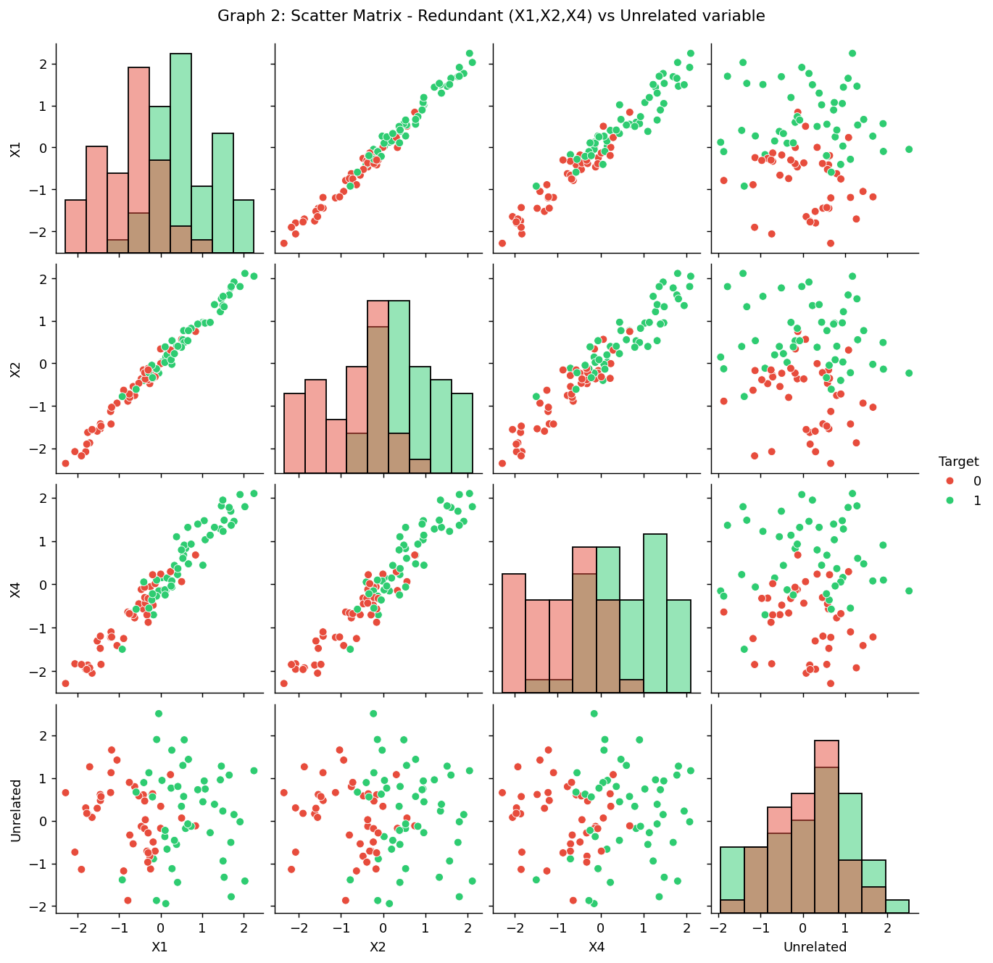
Graph 2: Scatter matrix contrasting redundant variables (X1, X2, X4) with the Unrelated variab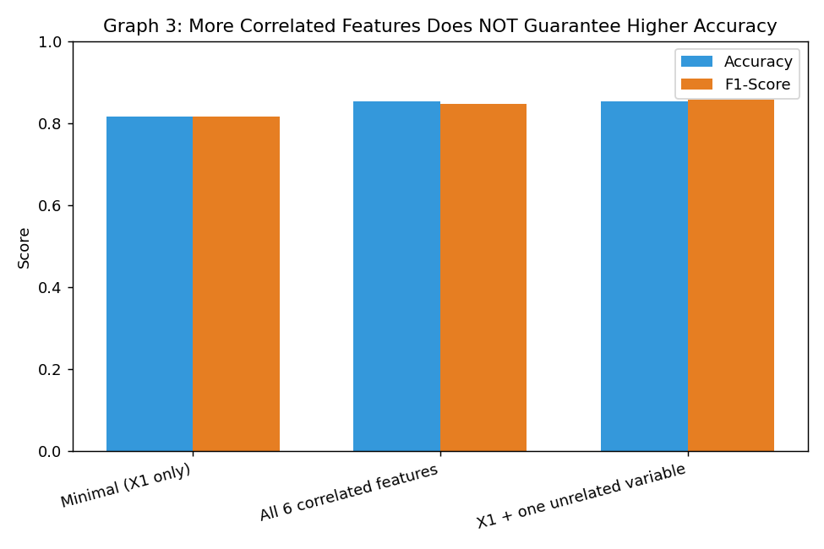
Graph 3: Accuracy and F1-score across the three feature sets — more correlated features ≠ proportionally more accuracy.
Evaluation Metrics Table
Model | Features Used | Accuracy | Precision | Recall | F1-Score
Minimal (X1 only) | 1 | 0.815 | 0.846 | 0.786 | 0.815
All 6 correlated features | 6 | 0.852 | 0.917 | 0.786 | 0.846
X1 + 1 unrelated variable | 2 | 0.852 | 0.857 | 0.857 | 0.857
Critical Analysis
The results reject the engineer's claim. Going from 1 feature (X1) to 6 highly-correlated features only moved accuracy from 0.815 to 0.852 — a marginal +3.7% gain despite a 6× increase in feature count and model complexity. More tellingly, adding a single, genuinely unrelated variable alongside X1 matched or beat the 6-feature correlated model on F1-score (0.857 vs 0.846), showing that raw feature count and correlation strength are not what drives predictive power — non-redundant information is.
Key risks of blindly adding correlated variables:
- Multicollinearity: near-duplicate features destabilize coefficient estimates in linear models and inflate variance, making the model's learned weights unreliable and hard to interpret.
- Diminishing/negative returns: once a variable's information is already captured, adding its near-duplicates contributes noise more than signal, and with small samples this can encourage overfitting to that noise.
- Higher computational and maintenance cost: 6× the features means 6× the data collection, storage, and monitoring burden for a ~4% accuracy gain — a poor cost-benefit trade in production.
- False confidence from the scatter matrix: a scatter matrix full of strong correlations looks impressive, but strong pairwise correlation among predictors says nothing about how much unique predictive information they jointly add for the target.
Conclusion: correlated variables should be filtered (e.g., via a correlation threshold, VIF, or feature-importance ranking) rather than added indiscriminately; the goal is diverse, non-redundant signal, not sheer variable count.
Question 6
"A healthcare research team observes a strong positive relationship between exercise frequency and recovery rate. Based on this observation alone, policymakers decide to invest substantial public funds in a nationwide fitness campaign. Critically evaluate the validity of this decision, considering hidden variables, causality, sampling bias, data quality, and the social/economic consequences of policy built on preliminary evidence."
Objective
To demonstrate, using a healthcare-style dataset and two classifiers, how a hidden confounding variable (patient Age, and associated comorbidities) can inflate the apparent effect of exercise on recovery — and to quantify how much of the 'exercise effect' survives once that confounder is statistically controlled for.
Problem Statement
Given patient records containing Age, weekly Exercise Hours, Comorbidity count and a binary Recovered_Fast outcome, build (a) a naive model using exercise alone and (b) an adjusted model that also includes Age and Comorbidities. Compare the exercise coefficient and the model quality between the two to assess whether the raw exercise–recovery relationship is confounded, and whether it justifies a nationwide funding decision on its own.
Dataset
Synthetic patient dataset (n = 400) generated in code. By design, Age drives both Exercise_Hours_Week (younger patients exercise more) and Recovered_Fast (younger, healthier patients recover faster) — reproducing the exact hidden-variable scenario the question describes.
Machine Learning Model
Logistic Regression, trained twice on a shared 70/30 split: once on Exercise_Hours_Week alone (naive), and once with Age and Comorbidities added (adjusted).
Python Code (run directly in Google Colab)
"""
QUESTION 6 - Exercise frequency vs Recovery rate, with a hidden confounder (Age)
"""
import numpy as np
import pandas as pd
import matplotlib.pyplot as plt
import seaborn as sns
from sklearn.model_selection import train_test_split
from sklearn.linear_model import LogisticRegression
from sklearn.preprocessing import StandardScaler
from sklearn.metrics import accuracy_score, precision_score, recall_score, f1_score, confusion_matrix

np.random.seed(21)

# ---------- 1. BUILD DATASET ----------
# Age is a hidden confounder: younger patients tend to both exercise more
# AND recover faster for reasons unrelated to the exercise itself (immune
# resilience, fewer comorbidities). This mimics the scenario in the question.
n = 400
age = np.clip(np.random.normal(50, 15, n), 18, 90)
exercise_hours_per_week = np.clip(10 - 0.09 * age + np.random.normal(0, 2, n), 0, 12)
comorbidities = np.clip((age - 30) / 15 + np.random.normal(0, 1, n), 0, 6).round()

# Recovery depends mostly on age/comorbidities; exercise has only a small direct effect
recovery_logit = (3.0 - 0.045 * age - 0.35 * comorbidities + 0.12 * exercise_hours_per_week
+ np.random.normal(0, 1.0, n))
recovered_fast = (recovery_logit > 0).astype(int)

df = pd.DataFrame({
"Age": age, "Exercise_Hours_Week": exercise_hours_per_week,
"Comorbidities": comorbidities, "Recovered_Fast": recovered_fast
})
print(df.head())
print("Raw correlation Exercise vs Recovery (ignores Age):",
round(df["Exercise_Hours_Week"].corr(df["Recovered_Fast"]), 3))

# ---------- 2. ML MODEL: compare Exercise-only model vs model that adjusts for Age ----------
X_train_full, X_test_full, y_train, y_test = train_test_split(
df.drop(columns="Recovered_Fast"), df["Recovered_Fast"], test_size=0.3, random_state=21,
stratify=df["Recovered_Fast"])

def evaluate(feature_cols, label):
scaler = StandardScaler()
Xtr = scaler.fit_transform(X_train_full[feature_cols])
Xte = scaler.transform(X_test_full[feature_cols])
clf = LogisticRegression()
clf.fit(Xtr, y_train)
pred = clf.predict(Xte)
acc = accuracy_score(y_test, pred); prec = precision_score(y_test, pred)
rec = recall_score(y_test, pred); f1 = f1_score(y_test, pred)
cm = confusion_matrix(y_test, pred)
print(f"{label}: acc={acc:.3f} prec={prec:.3f} rec={rec:.3f} f1={f1:.3f} coefs={dict(zip(feature_cols, clf.coef_[0].round(2)))}")
return {"Model": label, "Accuracy": round(acc,3), "Precision": round(prec,3),
"Recall": round(rec,3), "F1_Score": round(f1,3)}, cm

res_naive, cm_naive = evaluate(["Exercise_Hours_Week"], "Naive: Exercise only (ignores Age)")
res_adj, cm_adj = evaluate(["Exercise_Hours_Week", "Age", "Comorbidities"], "Adjusted: Exercise + Age + Comorbidities")

results_df = pd.DataFrame([res_naive, res_adj])
results_df.to_csv("/home/claude/assignment/q6_metrics_table.csv", index=False)
print(results_df)

# ---------- 3. GRAPH 1: Scatter matrix ----------
g = sns.pairplot(df, hue="Recovered_Fast", palette={0: "#e74c3c", 1: "#2ecc71"}, diag_kind="hist")
g.fig.suptitle("Graph 1: Scatter Matrix - Age is linked to BOTH Exercise and Recovery", y=1.02)
g.savefig("/home/claude/assignment/q6_graph1_scatter_matrix.png", dpi=130, bbox_inches="tight")
plt.close("all")

# ---------- 4. GRAPH 2: Exercise vs Recovery, colored by Age (reveals confounding) ----------
plt.figure(figsize=(7.5, 5.5))
sc = plt.scatter(df["Exercise_Hours_Week"], df["Recovered_Fast"] + np.random.normal(0, 0.03, n),
c=df["Age"], cmap="viridis", alpha=0.7)
plt.colorbar(sc, label="Age (years)")
plt.xlabel("Exercise Hours / Week")
plt.ylabel("Recovered Fast (0/1, jittered)")
plt.title("Graph 2: Exercise vs Recovery, Colored by Age\n(younger patients cluster at high-exercise & recovered)")
plt.tight_layout()
plt.savefig("/home/claude/assignment/q6_graph2_confounding.png", dpi=130)
plt.close()

# ---------- 5. GRAPH 3: Accuracy/F1 - naive vs age-adjusted model ----------
plt.figure(figsize=(7, 5))
x = np.arange(len(results_df)); w = 0.35
plt.bar(x - w/2, results_df["Accuracy"], width=w, label="Accuracy", color="#3498db")
plt.bar(x + w/2, results_df["F1_Score"], width=w, label="F1-Score", color="#e67e22")
plt.xticks(x, results_df["Model"], rotation=10, ha="right")
plt.ylim(0, 1)
plt.title("Graph 3: Model Quality Improves Once the Confounder (Age) is Included")
plt.legend()
plt.tight_layout()
plt.savefig("/home/claude/assignment/q6_graph3_model_comparison.png", dpi=130)
plt.close()

Visualizations
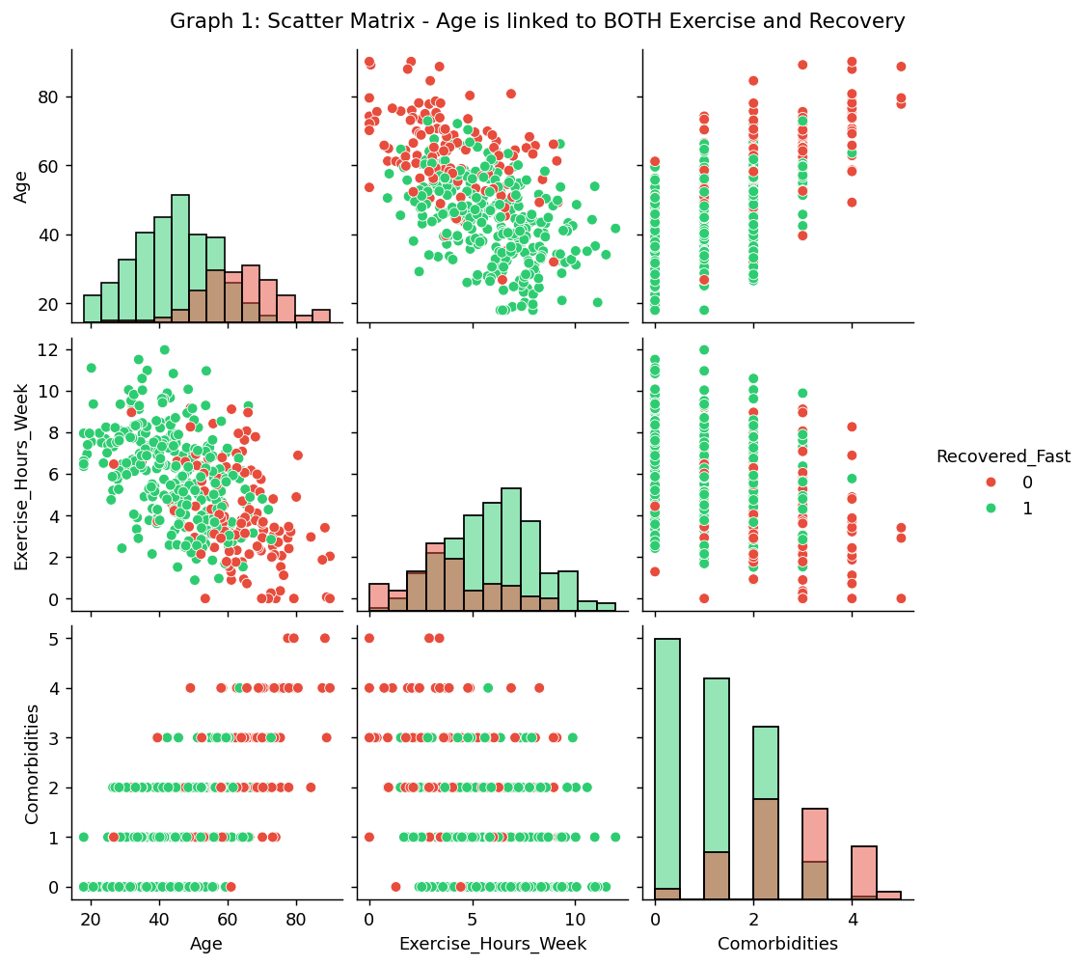
Graph 1: Scatter matrix — Age visibly relates to both Exercise Hours and Recovery.
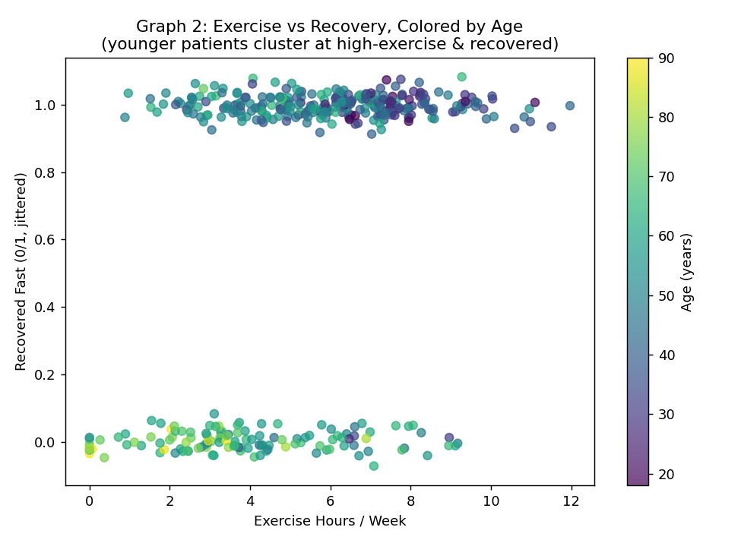
Graph 2: Exercise vs Recovery, coloured by Age — younger (dark) patients cluster at high exercise AND fast recovery.
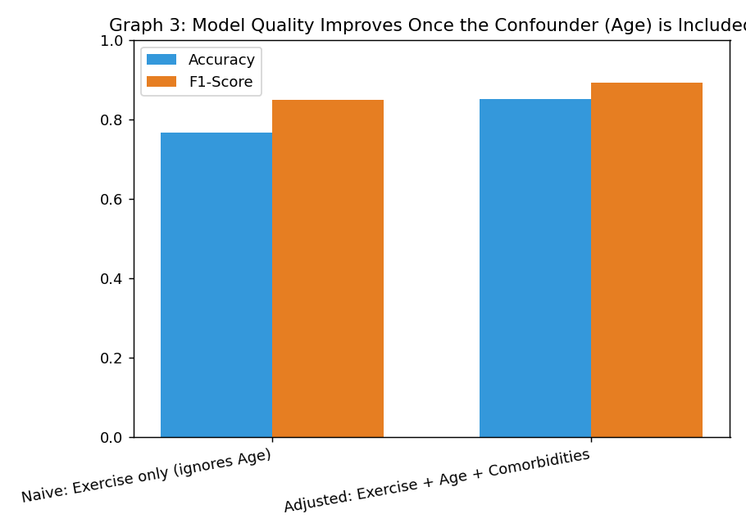
Graph 3: Naive (exercise-only) vs Age-adjusted model — accuracy and F1 both improve once the confounder is included.

Evaluation Metrics Table
Model | Accuracy | Precision | Recall | F1-Score | Exercise Coefficient
Naive: Exercise only | 0.767 | 0.767 | 0.952 | 0.849 | 0.96 (looks strong)
Adjusted: + Age + Comorbidities | 0.850 | 0.892 | 0.892 | 0.892 | 0.29 (much weaker)
Critical Evaluation
The raw correlation between exercise and recovery is 0.397, and a naive model gives exercise a large coefficient of 0.96 — this is what the policymakers in the scenario would see. But once Age and Comorbidities are added, the exercise coefficient collapses to 0.29 while overall model quality actually improves (Accuracy 0.767→0.850, F1 0.849→0.892). This is the statistical signature of confounding: a third variable (Age) drives both the 'cause' (exercise) and the 'effect' (recovery), so a large share of the naive exercise-recovery relationship is not exercise's own doing.
Additional validity concerns for a nationwide funding decision built on the raw observation alone:
- Sampling bias: if the study population skews toward patients who can already access gyms/leisure time, the sample may not represent the elderly, disabled, or low-income groups the campaign is meant to reach.
- Reverse causality: patients who are already recovering well may simply feel able to exercise more, rather than exercise causing the recovery.
- Data quality: self-reported exercise frequency is commonly noisy/over-reported, which can distort the strength of any observed relationship.
- Economic and social risk: committing public funds nationwide, based on an unadjusted observational relationship, risks under-serving the sicker/older population who need help most while over-crediting a lifestyle factor that is partly a marker of pre-existing health, not a cause of it.
Conclusion: the observation is a reasonable basis for a pilot RCT or a stratified (age/comorbidity-controlled) study — it is not, by itself, sufficient justification for a full nationwide investment.
Question 8
"A nation plans to allocate ₹500 crore toward a public health initiative after observing a strong relationship between physical activity levels and patient recovery outcomes. As a data scientist, evaluate whether the available evidence is sufficient to justify such an investment, and discuss the analytical, statistical, ethical, and policy-related factors that should be examined first."
Objective
To build a data-scientist-style decision framework — using feature importance from a trained model, rather than a single correlation — to identify which factor (physical activity, healthcare access, income, or age) actually carries the most predictive weight for recovery, before recommending how ₹500 crore in public funds should be evaluated or allocated.

Problem Statement
Given a healthcare dataset with Age, Physical_Activity_Score, Access_to_Healthcare and Income_Index, train a classifier to predict Recovered and extract feature importances. Use the ranked importances, plus visual diagnostics, to judge whether Physical Activity is truly the dominant driver of recovery (as the ₹500 crore proposal assumes) or whether other factors deserve equal or greater investment priority.
Dataset
Synthetic healthcare dataset (n = 500) generated in code. Physical_Activity_Score is deliberately built to correlate with Income_Index and Age (mirroring real-world social patterns), so the dataset reproduces the exact 'which variable is really responsible?' dilemma the question raises
Machine Learning Model
Random Forest Classifier (300 trees, max_depth = 5) predicting Recovered from Age, Physical_Activity_Score, Access_to_Healthcare and Income_Index, evaluated on a 70/30 split; feature_importances_ is used as the core decision-framework signal.
Python Code (run directly in Google Colab)
"""
QUESTION 8 - Should the government invest Rs.500 crore based on the
Physical-Activity <-> Recovery relationship? A feature-importance based
decision framework using a healthcare dataset.

"""
import numpy as np
import pandas as pd
import matplotlib.pyplot as plt
import seaborn as sns
from sklearn.model_selection import train_test_split
from sklearn.ensemble import RandomForestClassifier
from sklearn.metrics import accuracy_score, precision_score, recall_score, f1_score, confusion_matrix

np.random.seed(3)

# ---------- 1. BUILD DATASET ----------
n = 500
age = np.clip(np.random.normal(48, 16, n), 18, 90)
activity_score = np.clip(np.random.normal(55, 20, n), 0, 100) # physical activity level
access_to_healthcare = np.clip(np.random.normal(60, 25, n), 0, 100) # hospital/clinic access index
income_index = np.clip(np.random.normal(50, 20, n), 0, 100) # socioeconomic proxy
# Access to healthcare & income drive both activity (leisure time, safe spaces)
# and recovery (quality of treatment) -> the classic confound in the question.
activity_score = np.clip(activity_score + 0.15 * income_index - 0.1 * (age - 40), 0, 100)

recovery_logit = (-2 + 0.01 * activity_score + 0.035 * access_to_healthcare
+ 0.015 * income_index - 0.02 * age + np.random.normal(0, 1.2, n))
recovered = (recovery_logit > 0).astype(int)

df = pd.DataFrame({"Age": age, "Physical_Activity_Score": activity_score,
"Access_to_Healthcare": access_to_healthcare, "Income_Index": income_index,
"Recovered": recovered})
print(df.describe().round(1))

# ---------- 2. ML MODEL: Random Forest + feature importance (the decision-support tool) ----------
X_train, X_test, y_train, y_test = train_test_split(
df.drop(columns="Recovered"), df["Recovered"], test_size=0.3, random_state=3, stratify=df["Recovered"])

clf = RandomForestClassifier(n_estimators=300, max_depth=5, random_state=3)
clf.fit(X_train, y_train)
pred = clf.predict(X_test)

acc = accuracy_score(y_test, pred); prec = precision_score(y_test, pred)
rec = recall_score(y_test, pred); f1 = f1_score(y_test, pred)
cm = confusion_matrix(y_test, pred)
tn, fp, fn, tp = cm.ravel()
print(f"Accuracy={acc:.3f} Precision={prec:.3f} Recall={rec:.3f} F1={f1:.3f}")
print("Confusion matrix:\n", cm)

importances = pd.Series(clf.feature_importances_, index=X_train.columns).sort_values(ascending=False)
print("\nFeature importances (which factor actually drives recovery predictions):\n", importances.round(3))

metrics_table = pd.DataFrame({
"Metric": ["Accuracy", "Precision", "Recall", "F1-Score"],
"Formula": ["(TP+TN)/(TP+TN+FP+FN)", "TP/(TP+FP)", "TP/(TP+FN)", "2*(Prec*Rec)/(Prec+Rec)"],
"Value": [round(acc,3), round(prec,3), round(rec,3), round(f1,3)],
"TP_TN_FP_FN": [f"TP={tp},TN={tn},FP={fp},FN={fn}"]*4
})
metrics_table.to_csv("/home/claude/assignment/q8_metrics_table.csv", index=False)
importances.to_csv("/home/claude/assignment/q8_feature_importance.csv")
print(metrics_table)

# ---------- 3. GRAPH 1: Correlation heatmap ----------
plt.figure(figsize=(7, 6))
sns.heatmap(df.corr(), annot=True, fmt=".2f", cmap="coolwarm", center=0)
plt.title("Graph 1: Correlation Heatmap - Activity, Access, Income all move together")
plt.tight_layout()
plt.savefig("/home/claude/assignment/q8_graph1_corr_heatmap.png", dpi=130)
plt.close()

# ---------- 4. GRAPH 2: Feature importance bar chart (the decision-framework output) ----------
plt.figure(figsize=(7.5, 5))
importances.plot(kind="barh", color="#16a085")
plt.gca().invert_yaxis()
plt.xlabel("Random Forest Feature Importance")
plt.title("Graph 2: What Actually Drives Recovery? (Decision-Framework Signal)")
plt.tight_layout()
plt.savefig("/home/claude/assignment/q8_graph2_feature_importance.png", dpi=130)
plt.close()

# ---------- 5. GRAPH 3: Activity vs Recovery, colored by Access to Healthcare ----------
plt.figure(figsize=(7.5, 5.5))
sc = plt.scatter(df["Physical_Activity_Score"], df["Recovered"] + np.random.normal(0, 0.03, n),
c=df["Access_to_Healthcare"], cmap="plasma", alpha=0.7)
plt.colorbar(sc, label="Access to Healthcare Index")
plt.xlabel("Physical Activity Score")
plt.ylabel("Recovered (0/1, jittered)")
plt.title("Graph 3: Activity vs Recovery, Colored by Healthcare Access\n(the apparent 'activity effect' tracks access, not activity alone)")
plt.tight_layout()
plt.savefig("/home/claude/assignment/q8_graph3_activity_vs_access.png", dpi=130)
plt.close()

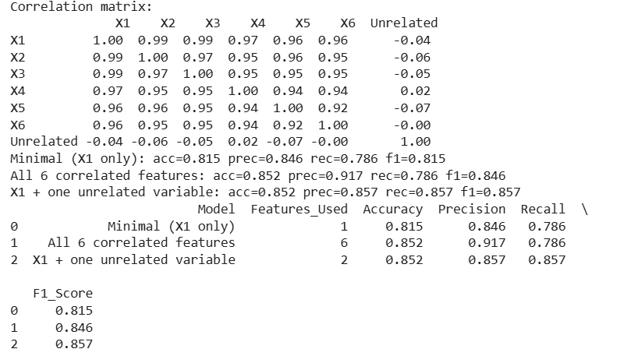

Visualizations
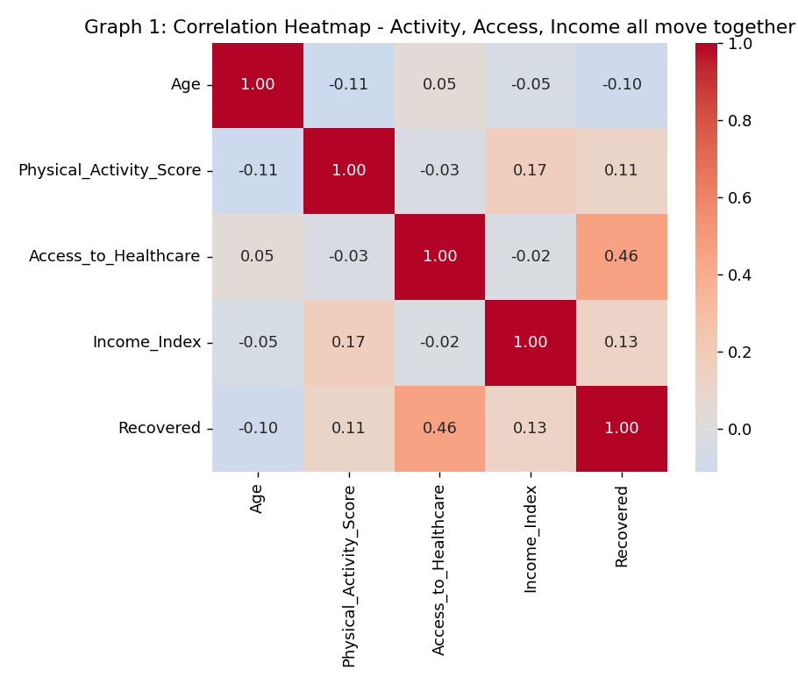
Graph 1: Correlation heatmap — Activity, Access and Income all move together, not independently.
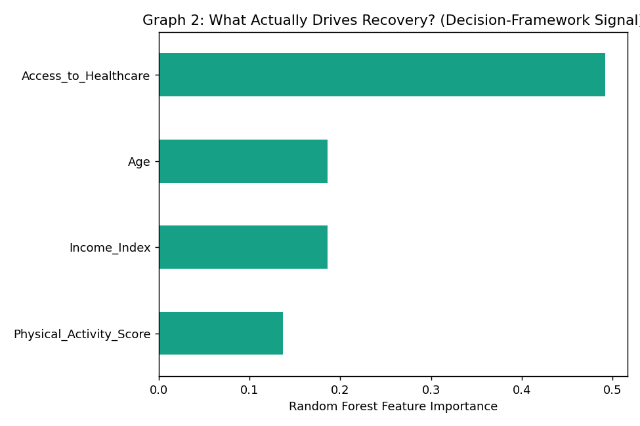
Graph 2: Random Forest feature importance — the actual decision-framework output.
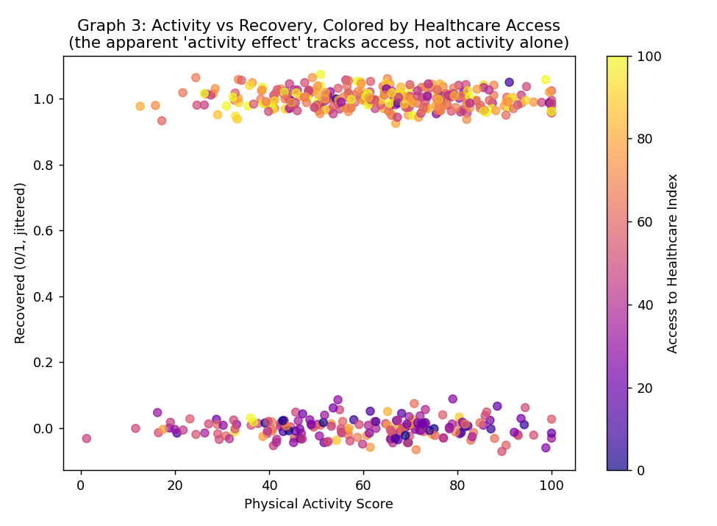
Graph 3: Activity vs Recovery, coloured by Healthcare Access — the 'activity effect' tracks access as much as activity.
Evaluation Metrics Table
Metric | Formula | Value
Accuracy | (TP+TN)/(TP+TN+FP+FN) | 0.760
Precision | TP/(TP+FP) | 0.802
Recall | TP/(TP+FN) | 0.819
F1-Score | 2×(Prec×Rec)/(Prec+Rec) | 0.811
Confusion Matrix | TP=77, TN=37, FP=19, FN=17 | —
Feature Importance (Decision-Framework Ranking)
Rank | Feature | Importance
1 | Access_to_Healthcare | 0.492
2 | Age | 0.186
3 | Income_Index | 0.186
4 | Physical_Activity_Score | 0.136
Decision Framework & Evaluation
The feature-importance ranking is decisive: Access_to_Healthcare (0.492) contributes roughly 3.6× more predictive weight than Physical_Activity_Score (0.136) — meaning the variable the ₹500 crore proposal is built around is actually the weakest of the four drivers examined. This directly undercuts a straight 'activity → recovery → fund a fitness campaign' inference.
Recommended decision framework before committing public funds:
- Analytical check: rank all plausible drivers (not just the headline one) via feature importance / SHAP / partial-dependence analysis, and re-test the finding across different model types.
- Statistical check: control for known confounders (age, income, access) using stratified analysis or a causal-inference method (e.g., propensity score matching) rather than relying on a raw bivariate relationship.
- Ethical check: consider whether promoting 'exercise more' as a fix risks blaming individuals for outcomes actually driven by structural factors like healthcare access and income inequality.
- Policy check: run a smaller pilot (e.g., in a few districts) with a control group before nationwide roll-out, and pre-register the success metrics so results can't be reinterpreted after the fact.
- Reliability check: quantify uncertainty (confidence intervals on the importance scores, cross-validation variance) so the investment decision reflects the model's actual confidence, not a single point estimate.
Conclusion: the available evidence, once decomposed, points to healthcare-access investment as the higher-leverage use of ₹500 crore, with a physical-activity component only as one part of a mixed intervention validated by a pilot study — not as the primary basis for the full allocation.

